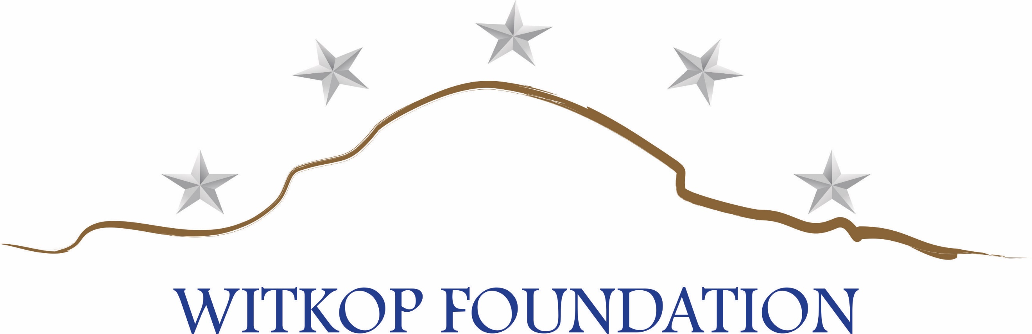

OPERATION PATRIOT SAFARI 2019 GILBERT MEMORIAL TRIP

REGISTRATION FORM / SPONSORSHIP AGREEMENT

COMPANY NAME_______________________________________________________

ADDRESS: _____________________________________________________________

CITY/STATE: __________________________ PHONE: ________________________

CONTACT NAME:_______________________________________________________

SIGNATURE:___________________________________________________________

IF YOU WOULD LIKE TO BE INVOICED FOR YOUR SPONSORSHIP, PLEASE CHECK HERE_____

SPONSORSHIP PACKAGES

Video Production (4 available) $5,000 Videographer and Video Production

Lodging/Meals/Laundry (7 available) $2,500 Jim, Ginger, Boston, Grayson, Bella, Aspen, Annalise

Airfare/Ground Transport (7 available) $1,750 Jim, Ginger, Boston, Grayson, Bella, Aspen, Annalise

Binoculars (7 available) $250 Jim, Ginger, Boston, Grayson, Bella, Aspen, Annalise

SPONSORED WILD GAME

Eland $2,200

Kudu $2,200

Red Hartebeest $1,000

Black Wildebeest $ 950

Impala $ 390 Springbok $ 390
Blesbok $ 390 Warthog $ 300
______________________________________________________________________________________

Make checks payable to: Witkop Foundation, Inc., 1119 N. Woodland Place, Sand Springs, OK 74063

OR: Go to www.witkopfoundation.org and make a donation in the amount of your chosen sponsor level.
Witkop Foundation is a 501(c)3 organization; FEIN 82-3454026

