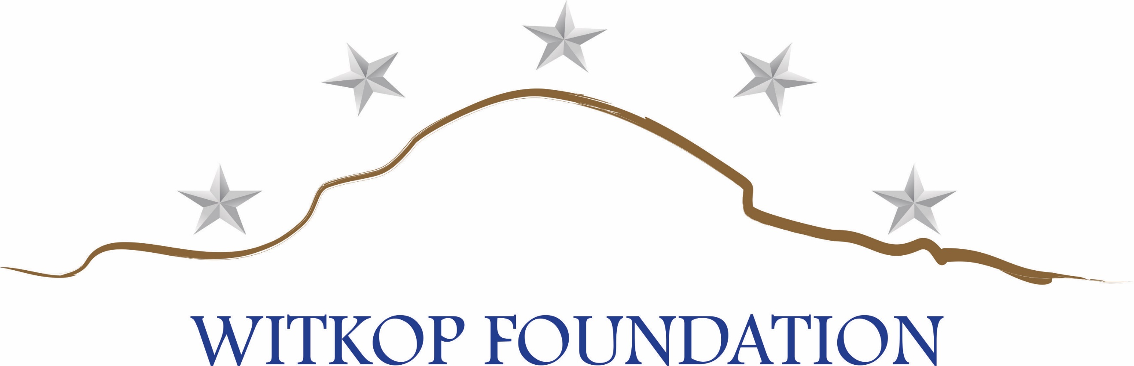

OPERATION PATRIOT HARVEST 2019 DOVE HUNT

REGISTRATION FORM / SPONSORSHIP AGREEMENT

COMPANY NAME_______________________________________________________

ADDRESS: _____________________________________________________________

CITY/STATE: __________________________ PHONE: ________________________

CONTACT NAME:_______________________________________________________

SIGNATURE:___________________________________________________________

IF YOU WOULD LIKE TO BE INVOICED FOR YOUR SPONSORSHIP, PLEASE CHECK HERE_____

SPONSORSHIP PACKAGES

Wing Commander (2 available) $5,000 4+4 hunters (8 total guns)*

Squadron Commander (4 available) $3,500 3+3 hunters (6total guns)*

Flight Commander (4 available) $2,500 2+2 hunters (4total guns)*

Range Rider Cart $2,000 8 Cart sponsorships are available

Hospitality Tent (2 available) $1,500 Includes Dove Cook-off after hunt

Hay Bales Sponsors $ 500 40 Sponsorships available

Individual sponsored hunter $ 250 You provide name of hunter

ADDITIONAL SPONSORSHIPS

Event T-Shirt (2 available) $1,000 Event Chair/Buckets $1,000

Event Hats (1 available) $1,000 Event Water Bottles $ 500

Event Ammunition (Unlimited) $ 500 Event Safety Glasses $ 500
________________________________________________________________________________
Make checks payable to: Witkop Foundation, Inc. Credit cards accepted: VISA, MC, AMEX, DISCOVER
OR: Go to www.witkopfoundation.org and make a donation in the amount of your chosen sponsor level.
Witkop Foundation is a 501(c)3 organization; FEIN 82-3454026

Account number:_________________________________________________________________________

Name on Card: __________________________________________________________________________

Expiration Date: __________________ CVV:_________Signature__________________________________ * preferred shooting locations/shotgun shells/loaner shotguns/signage/recognition

