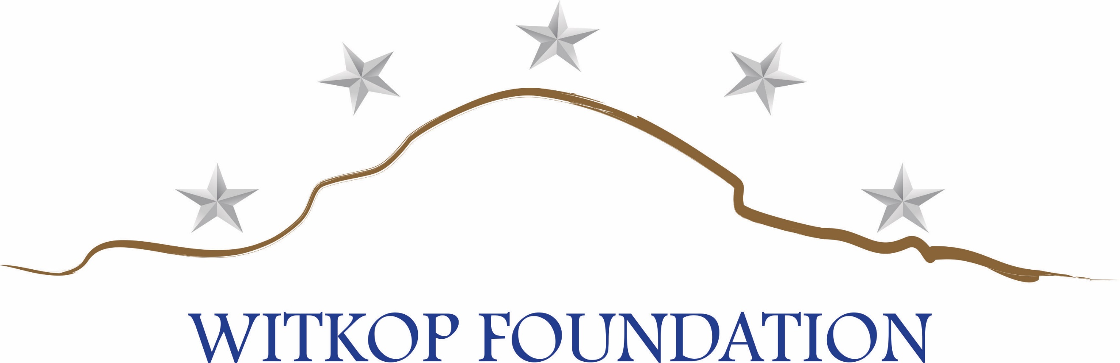

OPERATION PATRIOT HARVEST 2019 DOVE HUNT

REGISTRATION FORM / SPONSORSHIP AGREEMENT

COMPANY NAME_______________________________________________________

ADDRESS: _____________________________________________________________

CITY/STATE: __________________________ PHONE: ________________________

CONTACT NAME:_______________________________________________________

SIGNATURE:___________________________________________________________

IF YOU WOULD LIKE TO BE INVOICED FOR YOUR SPONSORSHIP, PLEASE CHECK HERE_____

SPONSORSHIP PACKAGES

Mission Commander (2 available) $5,000 4 Company Hunters plus 4 Veteran Hunters

Squad Commander (4 available) $3,500 3 Company Hunters plus 3 Veteran Hunters

4 Ship (4 available) $2,500 4 Company Hunters plus 2 Veteran Hunters

Range Rider Cart $2,000 4 Cart sponsorships are available

Hospitality Tent $1,500 Includes Dove Cook-off after hunt

Hay Bales Sponsors $ 200 40 Sponsorships available

Individual $ 250 Please provide name of hunter

ADDITIONAL SPONSORSHIPS

Event T-Shirt $1,000 Event Chair/Buckets $1,000

Event Hats $1,000 Event Water Bottles $ 500

Event Ammunition $ 500 Event Safety Glasses $ 500
________________________________________________________________________________
Make checks payable to: Witkop Foundation, Inc. Credit cards accepted: VISA, MC, AMEX, DISCOVER
OR: Go to www.witkopfoundation.org and make a donation in the amount of your chosen sponsor level.
Witkop Foundation is a 501(c)3 organization; FEIN 82-3454026

Account number:_________________________________________________________________________

Name on Card: __________________________________________________________________________

Expiration Date: __________________ CVV:_________Signature__________________________________

